**PEAS SET ONE**

**MOCK EXAMINATIONS 2016**

**456/2 MATHEMATICS PAPER TWO**

**2 HOURS 30 MINUTES**

**INSTRUCTIONS TO CANDIDATES:**

**Answer all questions in section A and any five questions from section B.**

**Any additional questions (s) answered from section b will not be marked.**

**All necessary calculations must be done on the same page as the rest of the answer. No paper should be given for rough work.**

**Graph Paper is provided.**

**Silent, non-programmable scientific calculators and mathematical tables may be used.**

**SECTION A (40 MARKS)**

**ANSWER ALL QUESITONS IN THIS SECTION**

1. Find the highest common factor (H.C.F) of 252, 294 and 546. **4 marks**
2. All the 53 students in S4 of Kiira View play at least one of the games football or volley ball.39 play football while 27 play volleyball. How many play both games. **4 marks**
3. Given f(x) = 3x-5

7

(a). find fˉ¹(x), the inverse of f(x).

(b). Hence, find the value of fˉ¹(4), **4marks**

1. Find the equation of the line passing through the points A(-6,2) and B(-8,-3)

4 Marks

1. A solid wooden box is 4m long, 2m wide and 50cm high, Find the total surface area of the box in m². 4marks
2. Given that $\underline{m}$ = $\left(\begin{aligned}4 \\ -6\end{aligned}\right)$ and $\underline{n}$ = $\left(\begin{aligned}13 \\ 8\end{aligned}\right)$ find the length of P and P =3n-2b

**4 marks**

1. Without using tables or a calculator, evaluate Log₁ₒ7 - log₁ₒ56+log₁ₒ800

4 marks

1. Diana deposited Shs. 500,000 in Barclays Bank. The bank gives a compound interest of 18% per annum. Calculate the interest she obtained from the bank after 2 years **4 marks**
2. Two cups are similar, the smaller one has a height of 6cm while the bigger one has a height of 18cm. Given that the volume of the smaller cup is 50cmᶟ, determine the volume of the bigger cup. **4 marks**

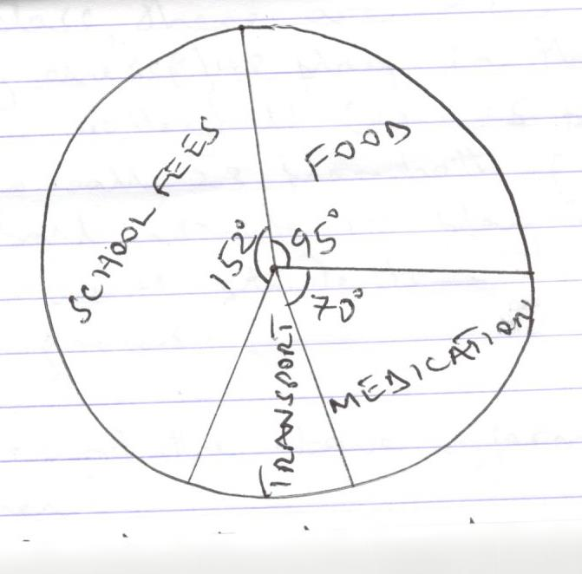

The pie-chart above shows how a parent spends his monthly salary on only four vital items. If the parent pays Shs. 228,000 on school fees every month, determine.

a). The parents monthly salary

b). How much money does the parent spend on transport every month.

**4 marks**

**SECTION B (60 MARKS)**

**ANSWER ANY FIVE QUESTIONS FROM THIS SECTION**

1. a). Express 2.4666… as an improper fraction in its simplest form

b). Express $\frac{6\sqrt{7}}{\sqrt{7}-\sqrt{5}}$ in the form a+b $\sqrt{c}$ where a,b and c are constants. Hence state the values of a,b and c.

c). Given that m= $\frac{b²+3ut}{b},$ express u in terms of b, m and t.

(12 marks)

1. In a class, there are 72 students, of these 30 play chess (C), 48 play football (F), while 41 play volleyball (V). 15 play both chess and football, 23 play both football and volleyball while 19 play both chess and volleyball.4 students do not play of these games.
2. Represent the above information on a venn diagram. (8 marks)
3. Find the number of students who pally all the three games. (2 marks)
4. If a student is selected at random from the class, find probability that the student plays at least two of the games. (2 marks)
5. a). Express $x^{2}+8x-65 in the form$ (x+a)²+b.

Hence, solve the equation x²+8x-65=0 6 marks

b). Given that f (x) = $\frac{x+5}{2}$ and f (x) = $\frac{1-3x}{3}$, determine the values of x

for which fg(x) = $\frac{x^{2}+2x-20 }{6}$**6 marks**

1. In the diagram below, D is the mid-point of $\overline{BC}$, $\overline{AF}$ = $\overline{FC}$ and $\overline{AE}$ = 2 $\overline{ED}$. Given that $\overline{AC}$ = b and $\overline{AB}$ = $\underline{c}$

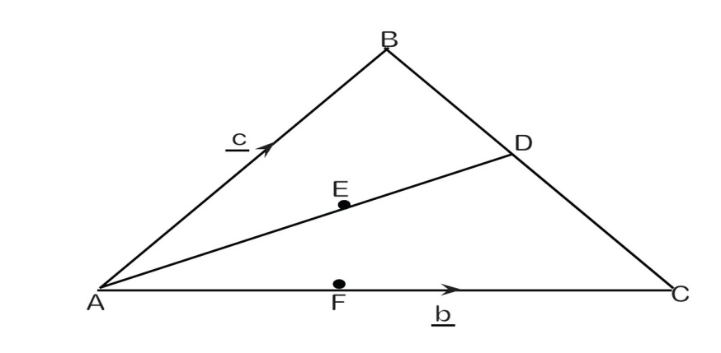

**a).** Find the following vectors in terms of b and c

i. $\overline{AD}$

ii. $\overline{BE}$

iii. $\overline{BF}$

7 marks

b) Show that B, E and F lie on a straight line **5 marks**

1. Soroti is 340 km away from Kampala. At 6.00 am a car travelling at a steady nonstop speed of 60kmhr¯¹ leaves Kampala for Soroti. One hour and 20 minutes later, YY coach leaves Kampala for Soroti traveling on the same route at a steadynonstop speed of 100km hr¯¹.

a). Using scales of 2cm to represent 40 km on the vertical axis and 3cm to represent 1 hour on the horizontal axis, draw on the same axes graphs of the journey of the two vehicles. **6marks**

b). Using your graphs, estimate the:

1. Time at which the YY coach overtakes the car
2. Distance from Kampala at which the YY Coach overtakes the car
3. Time when YY Coach arrives in Soroti
4. Time taken by the YY coach driver to wait for the driver of the car in Soroti
5. The figure below shows a right pyramid ABCDV on a rectangular base.

$\overline{AB}$ = $\overline{DC}$ =32cm, $\overline{BC}$ = $\overline{AD}$ =24cm, $\overline{AV}$ = $\overline{BV}$ = $\overline{CV}$ = $\overline{DV}$ =25cm.

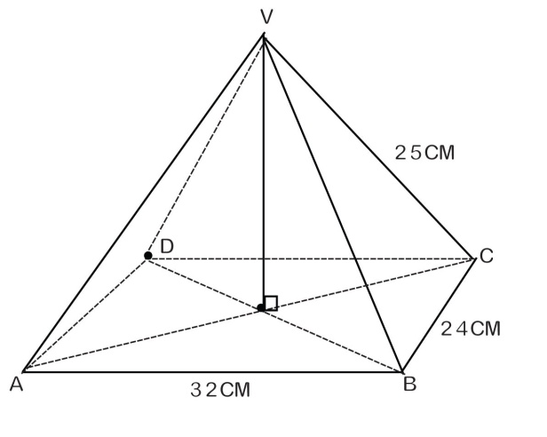

Calculate the

1. Height of the pyramid, OV (5marks)
2. Volume of the pyramid (2 marks)
3. Angle between AV and the base ABCD (2 marks)
4. Angle between plan ADV and plane BCV (2 marks)
5. The head teacher Kiira View earns a gross salary of Shs. 890,000 per month which includes an allowance of Shs. 130,000 tax free. The rest of his income is subjected to income tax as shown in the table below:

|  |  |
| --- | --- |
| Taxable Income in Shs. | Tax rate in % |
| 0 - 50,000 | 9.5 |
| 50,001 - 100,000 | 16.5 |
| 100,001 - 200,000 | 20.0 |
| 200,001 - 400,000 | 25.0 |
| Above 400,000 | 30.0 |

Calculate the:

1. Head teachers taxable income 2marks
2. Monthly income tax paid by the head teacher 8 marks
3. Percentage of his monthly gross salary that goes to paying monthly income taxes. 2marks.